Mini Project
On

CHATGPT CLONE APPLICATION
Submitted in Partial Fulfillment of the Requirement for the Award of the Degree of

BACHELOR OF TECHNOLOGY (INFORMATION TECHNOLOGY)


To

VEER BAHADUR SINGH PURVANCHAL UNIVERSITY,
JAUNPUR

Under the Supervision of

Mr. Ravi Kant Yadav (Assistant Professor)

Mr. Ritesh Srivastava (Assistant Professor)

Submitted By:

Vikrant Singh (22001304093)

DEPARTMENT OF COMPUTER SCIENCE & ENGINEERING UNSIET VBS PU JAUNPUR

1 February 2023-24

ACKNOWLEDGEMENT

Apart from my effort, the success of the project depends largely on the encouragement and guidelines of many others. We take this opportunity to express our gratitude to the people who express have been instrumental in the successful completion of this project.

I would like to express my deep and sincere gratitude to my supervisor Mr. Ravi Kant Yadav Sir , who gave me his full support and encouraged me to work in an innovative and challenging project for educational field. His wide knowledge and logical thinking gave me right direction all the time.

I am deeply grateful my project mentor for his help and support provided at every step of the project.

VIKRANT SINGH

DECLARATION

This is to certify that the project report entitled “ChatGPT Clone Application” is done by me is an authentic work carried out for the partial fulfilment of the requirements for the award of the Degree in “Information Technology” under the guidance of Mr. Ravi Kant Yadav. The matter embodied in this project work has not been submitted earlier for award of any degree to the best of my knowledge and belief.

VIKRANT SINGH

CERTIFICATE

It is certified that, this project entitled "Samachar India", submitted by (Vikrant Singh) in partial fulfilment of the requirement for the award of Bachelor of Technology (Information Technology) degree from VBS Purvanchal University, Jaunpur, is record of students own study carried under my/our supervision. This Project report has not been submitted to any other university or institution for the award of any degree.

Project Guide

Mr. Ravi Kant Yadav
(Assistant Professor)
Mr. Ritesh Srivastava
(Assistant Professor)

Date : 1 February 2024
Place: UNSIET,Jaunpur
Table of Contents

- Introduction…………………………………………………………
  - Introduction………………………………………………………………
  - Objectives………………………………………………………………...
  - Problem Definition……………………………………………………….

- System Analysis…………………………………………………...
  - Objective……………………………………………………………………
  - SDLC Phases………………………………………………………………
    - Preliminary Investigation…………………………………………
    - System Analysis………………………………………………….
    - System Design……………………………………………………
    - Coding……………………………………………………………
    - Testing……………………………………………………………
    - Implementation…………………………………………………...
    - Maintenance…………………………………………………….

- Software Requirement Specification………………………………
  - Hardware Requirement………………………………………………..
  - Software Requirement…………………………………………………
  - Support Maintenance…………………………………………………

- Backend Design……………………………………………………...
  - Description Of Classes and Methods(Model.py)…………………………
  - Defined URLs(urls.py)…………………………………………………….

- Data Modeling………………………………………………………
  - List of Tables……………………………………………………………
  - Structure of Tables………………………………………………………

- Input-Output Forms………………………………………………..
  - Project Screenshot……………………………………………………….
  - Project Coding…………………………………………………………...

- Future Scope…………………………………………………………
- Conclusion……………………………………………………………
- References…………………………………………………………….

LIST OF FIGURES

- SOFTWARE DEVELOPMENT LIFE CYCLES……………………….
- DEVELOPMENT PHASES…………………………………………….

INTRODUCTION

1.1 INTRODUCTION

The primary purpose of this ChatGPT clone is to empower developers with a foundation for building interactive and intelligent conversational applications. By offering a simplified yet robust implementation, developers can seamlessly integrate natural language understanding and generation into their projects.

The ChatGPT Clone App leverages advanced natural language processing techniques to generate human-like responses based on user input. It is designed to understand and generate text in a conversational manner, making it suitable for a wide range of applications. This project is an exciting exploration into the capabilities of language models and their practical implementation.

1.2 OBJECTIVES

- Ease of Integration: Provide a straightforward integration process for developers with clear documentation and examples.
- Customization: Allow developers to tailor the chatbot's behaviour and appearance to suit the specific requirements of their applications.
- Scalability: Design the application to handle varying degrees of complexity and scale, ensuring optimal performance in different environments.

1.3 PROBLEM DEFINITION

This documentation is intended for developers, software engineers, and AI enthusiasts who want to incorporate a ChatGPT-like conversational AI into their projects. Whether you're a seasoned professional or a hobbyist exploring the possibilities of natural language processing, this documentation will guide you through the setup, customization, and integration of the ChatGPT clone.

SYSTEM ANALYSIS

  - Objective:

It is a process of collecting and interpreting facts, identifying the problems, and decomposition of a system into its components.

System analysis is conducted for the purpose of studying a system or its parts in order to identify its objectives. It is a problem-solving technique that improves the system and ensures that all the components of the system work efficiently to accomplish their purpose.

Analysis specifies what the system should do.

2.2 SDLC Phases:

System Development Life Cycle (SDLC) mainly consists of the following 7 phases which can be detailed: -

2.2.1 Preliminary Investigation: -

This is the first phase of the system development life cycle. In this phase we tend to find out the needs of the client-what exactly does the client want? Before the development of any system the important point is to know the needs, objectives and scope of the system.

- Feasibility Study: -

Feasibility study is the step of preliminary study of the system development life cycle. Things are always easy at the beginning in any software process. In fact, nothing is in feasible with unlimited time and resources. But it is not the fact. So, practically we must do in limited resources in a restricted time margin. So, for the system to be feasible, following points we must consider. The feasibility study is conducted to check whether the candidate system is feasible.
- Technical Feasibility:

This is an important outcome of preliminary investigation. It comprises of following questions:
- Can the work of project bed one with the current equipment, existing software and available manpower resource?

- If Technology is required what are the possibilities that it can be developed?

- Economic Feasibility:

It deals with question related to the economy. It comprises of the following questions: -

- Are there sufficient benefits in creating the system to make the cost acceptable?
- Are the costs of not creating the system so great that the project must be undertaken?

- Legal Feasibility:

It deals with the question related to the legal issues. It comprises of the following questions:-

- Contract Signing

- Software License agreement

- Issues related to cyber laws.

- Legal issues relating to the manpower contract.

- Operational Feasibility:

The operational feasibility consists of the following activity: -

- Will the system be useful if it is developed &implemented?
- Will there be resistance from employee?

- Social & Behavioral Feasibility:

It deals with the various issues related to the human behavior like: -

- Whether the user be able to adapt a new change or not?
- Whether the ambiance we are providing suits the user or not?
- Request Approval: -

Request approval is the preliminary investigation phase of system development lifecycle. Request approval is the phase in which all the requirements which would be provide in the system are stated. The request approval is a sort of agreement between the client and the company which is building this software. Both the parties should be mutually agreed on the stated requirements.

2.2.2 System Analysis: -

System analysis is the phase following the phase of the request approval. In this phase we tend to analyze the overall system which we have to build. System analysis is the crucial part in SDLC.

    - System Design: -

System design means the designing of the system. The System can be done in either of the following two ways: - ( Logical System Design & Physical System Design)

2.2.4 Coding:

Coding is the phase in which a developer codes using any programming languages. Coding constitutes only 20% of the whole and which is easier to write. The coding work is also done in the teams; development of the system is usually done under the modular programming style, which can either top-down approach or bottom-up approach.

2.2.5 Testing:

Testing is the phase in which the system that has been developed is tested. Testing comprises of the 60% of the overall development of the system. Testing of the system is important because testing aims to uncover the different errors in the system. There are various different testing techniques that can be used for the testing of the system.

2.2.6 Implementation:

Implementation process involved the installation of software on user's side. Implementation process depends on type of a system & various. Opting for suitable conversion approach is a step implementation. The conversion processes are as follows: -

- Parallel Conversion
- Direct Conversion Approach
- Pilot Conversion Approach
- Phase In Conversion Approach

2.2.7 Maintenance :-

Merely developing the system is not important but also maintenance is important. The company that has built the system provides for some time free of cost maintenance to the client and after that period it is usually a paid service.
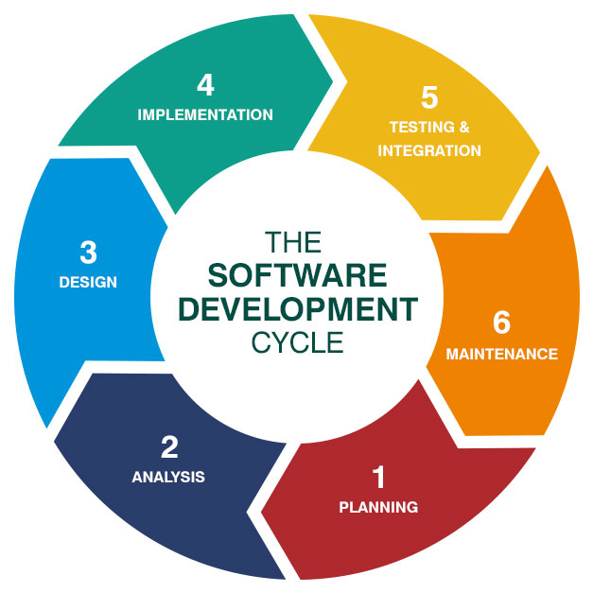

Fig-01

SOFTWARE HARDWARE REQUIREMENT SPECIFICATION

A requirements specification for a software system is a complete description of the behavior of a system to be developed and it includes a set of use cases that describe all the interactions the users will have with the software. In addition to use cases, the SRS also contains non-functional requirements.

Non-functional requirements are requirements which impose constraints on the design or implementation (such as performance engineering requirements, quality standards, or design constraints) Requirements are a sub-field of software engineering that deals with the elicitation, analysis, specification, and validation of requirements for software.

The software requirement specification document enlists all necessary requirements for project development. To derive the requirements, we need to have clear and thorough understanding of the products to be developed. This is prepared after detailed communications with project team and the customer.

3.1 SERVER-SIDE HARDWARE REQUIREMENT:

- AMD Athlon 64 with processor speed 2.8 or more

- 256 DDR Ram

- 40 GB Hard disks

- Interface card

- IIS

- CD-Drive

3.2 SERVER-SIDE SOFTWARE REQUIREMENT:

- Windows

- Python 3.7 and PyCharm IDE 2021.3

- OpenAI Tools

CLIENT-SIDE HARDWARE REQUIREMENT:

- Processor Dual core-based computer

- 4 GB Minimum RAM

- 20 GB HDD

- 100 Mbps LAN

- Web Browser

TO DEVELOP THIS PROJECT THE VARIOUS SOFTWARE RESOURCES ARE USED.

Front End - HTML-CSS & JavaScript

Back End - OpenAI

Web Server - Apache Server

Technology - Python technology

Code-Behind Language - Python

IDE - PyCharm

3.3 SUPPORT AND MAINTENANCE:-

One-year free support for rectifying system bugs including front end and beck end will be provided. During warranty period Software Engineers will be responsible for removing bugs and improving it. After one year support can be extended @ 20% of the total product deployment cost.

3.3.1 SYSTEM DESIGN APPROACH

3.3.1.1 Top-Down designing:

The top-down designing approach started with major components of the system. It is a stepwise refinement which starts from an abstract design, in each steps the design is refined two or more concrete levels until we reach a level where no-more refinement is possible or not needed.

3.3.1.2 Bottom-Up designing:

In bottom-up designing the most basic and primitive components are designed first, and we proceed to higher level components. We work with layers of abstractions and abstraction are implemented until the stage is reached where the operations supported by the layer is complete.
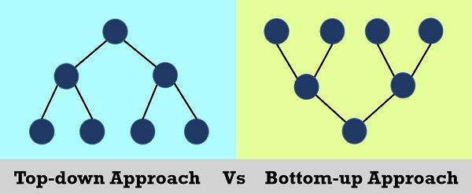

Fig – 02

3.3.2 Following Approach:

In this project we are following Mixed Approach i.e. A combination of top-down and bottom- up. We are developing some of the components using top-down designing approach (e.g., The Web Pages) and some components in bottom-up designing approach (e.g., the middle tier classes).

4. BACKEND DESIGN

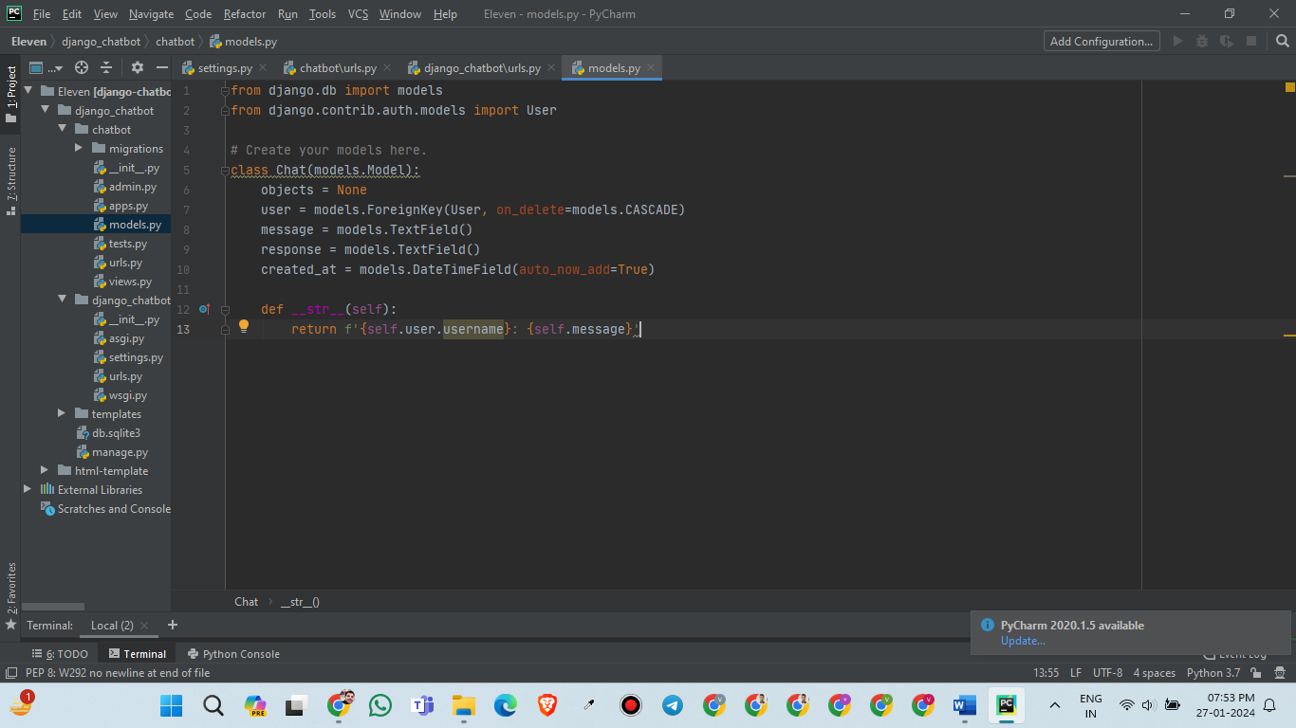
4.1 Description of Classes and Methods (model.py)

4.2 Defined urls (urls.py)

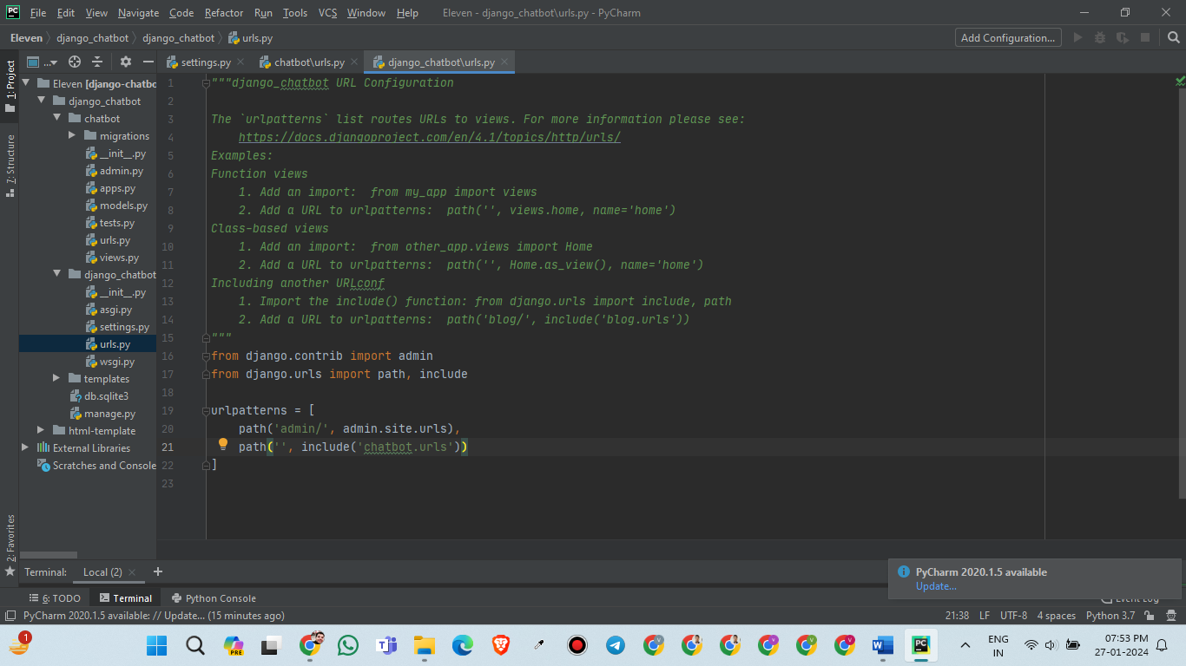
Project Level-URL.P

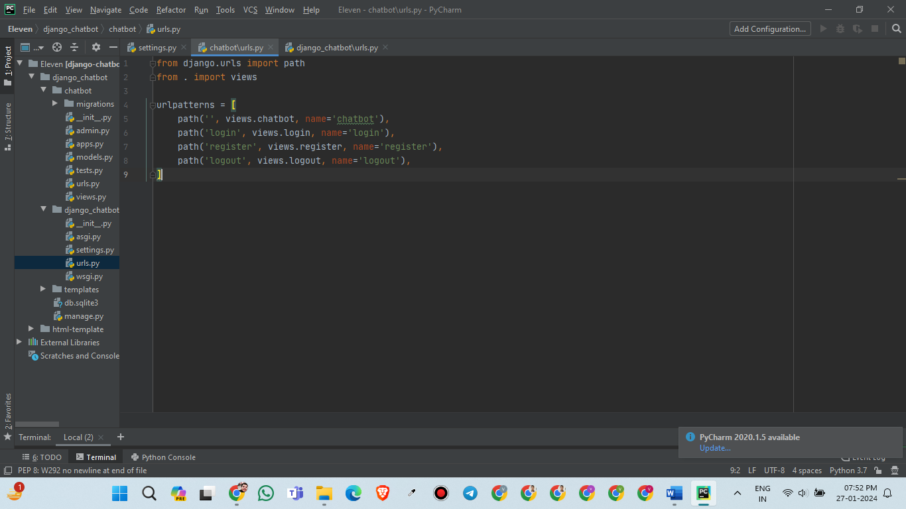
APP LEVEL – URLS.PY

5. DATA MODELING

5.1 LIST OF TABLES:

5.1.1. Group Table

5.1.2 User Table

5.1.3 Contact Info Table

5.1.4 Product Table

5.1.5 Subcategory Table
5.2 STRUCTURE OF TABLES:

5.2.1 Product Table
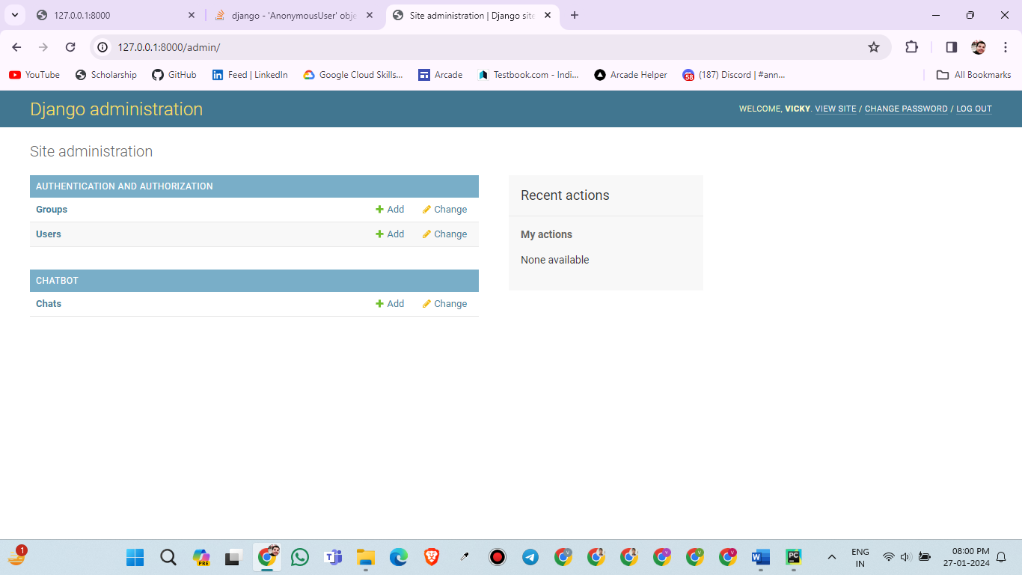

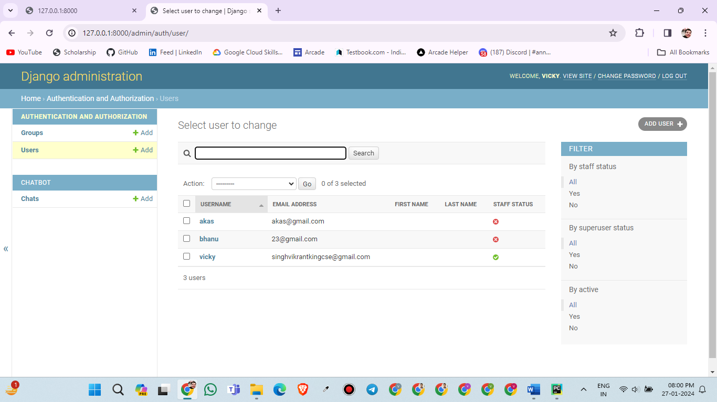
User Table:
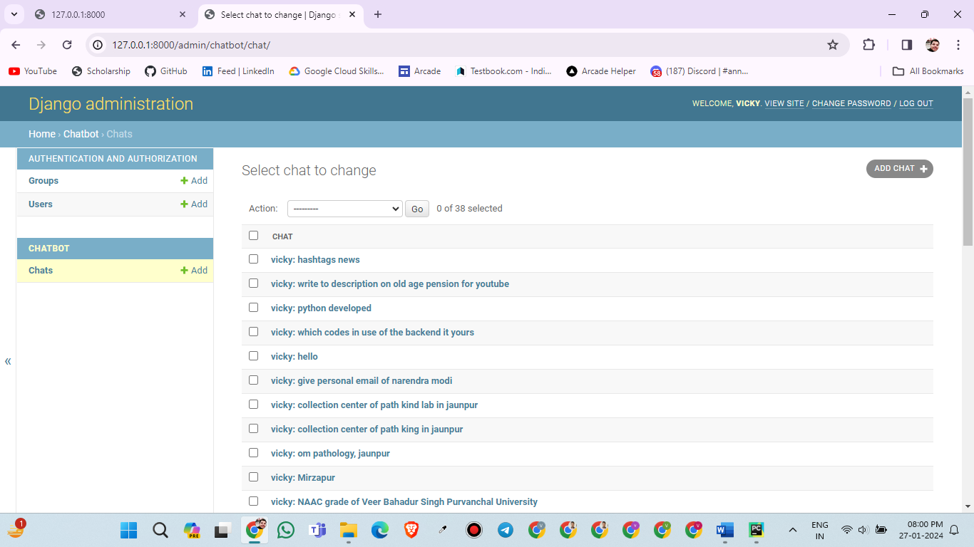
Chat Table :

6. Input-output Forms(SCREENSHOTS AND CODING)

6.1 Register.html & Login.html

6.1.1 SCREENSHOTS
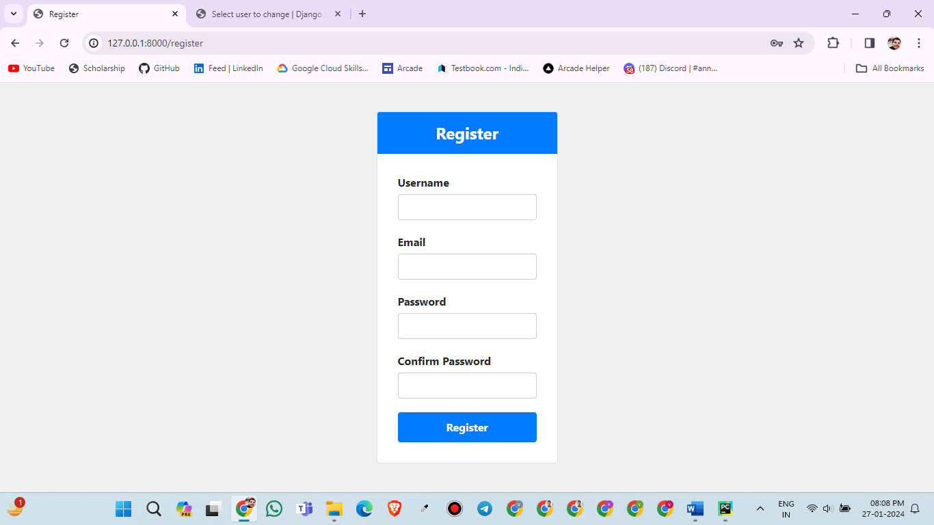
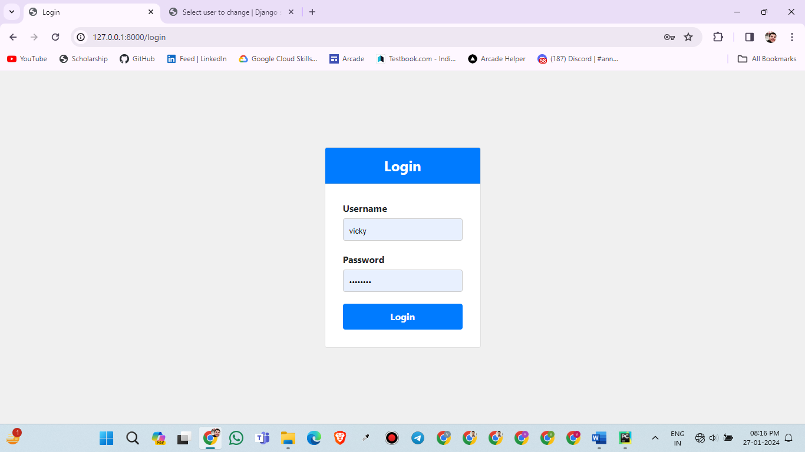

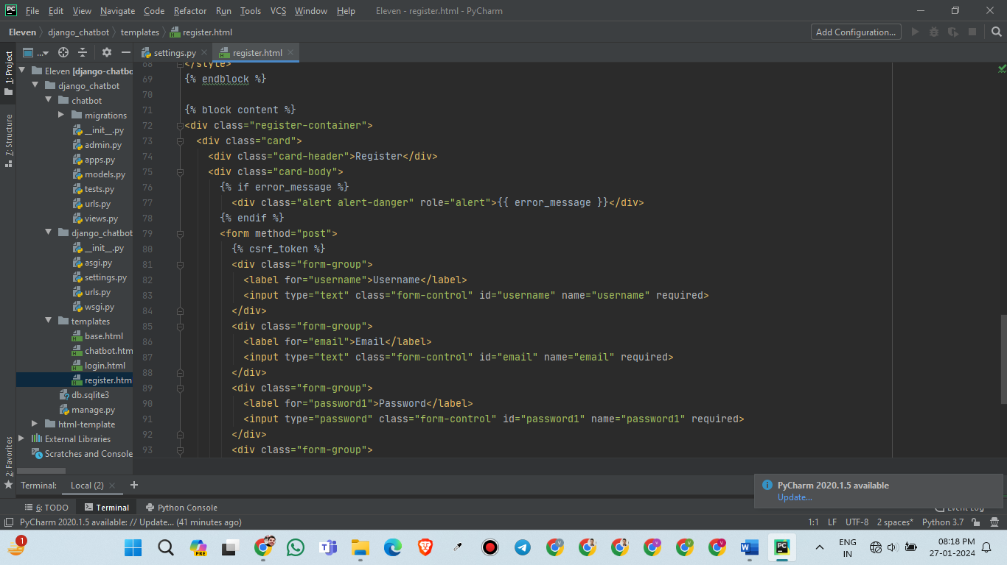
6.1.2 CODING(register.html)
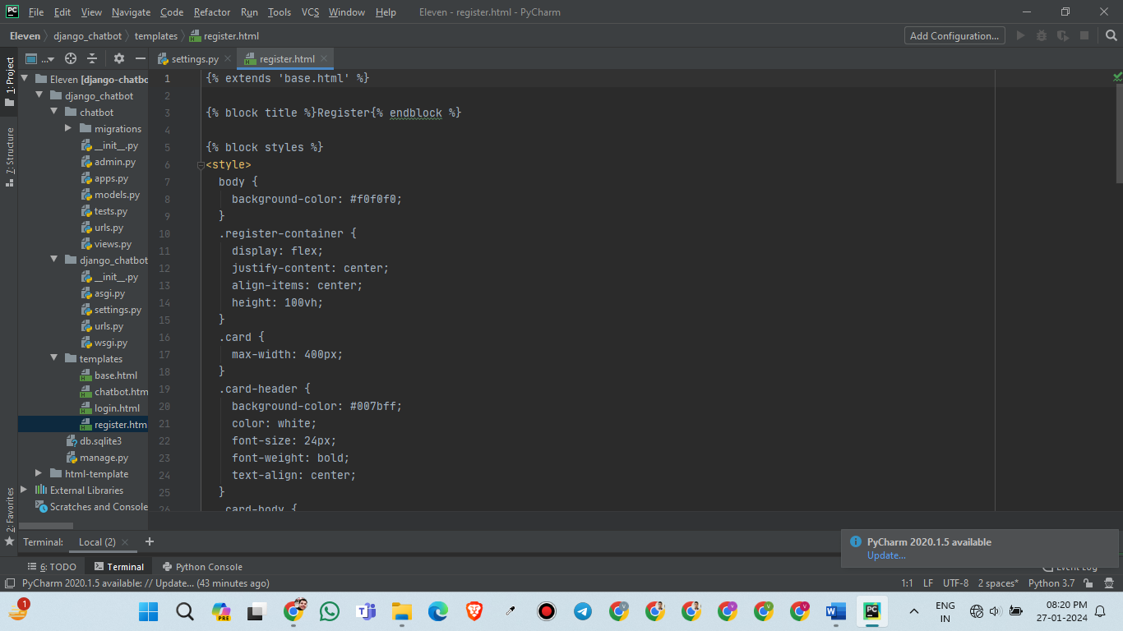

6.2 Login.html
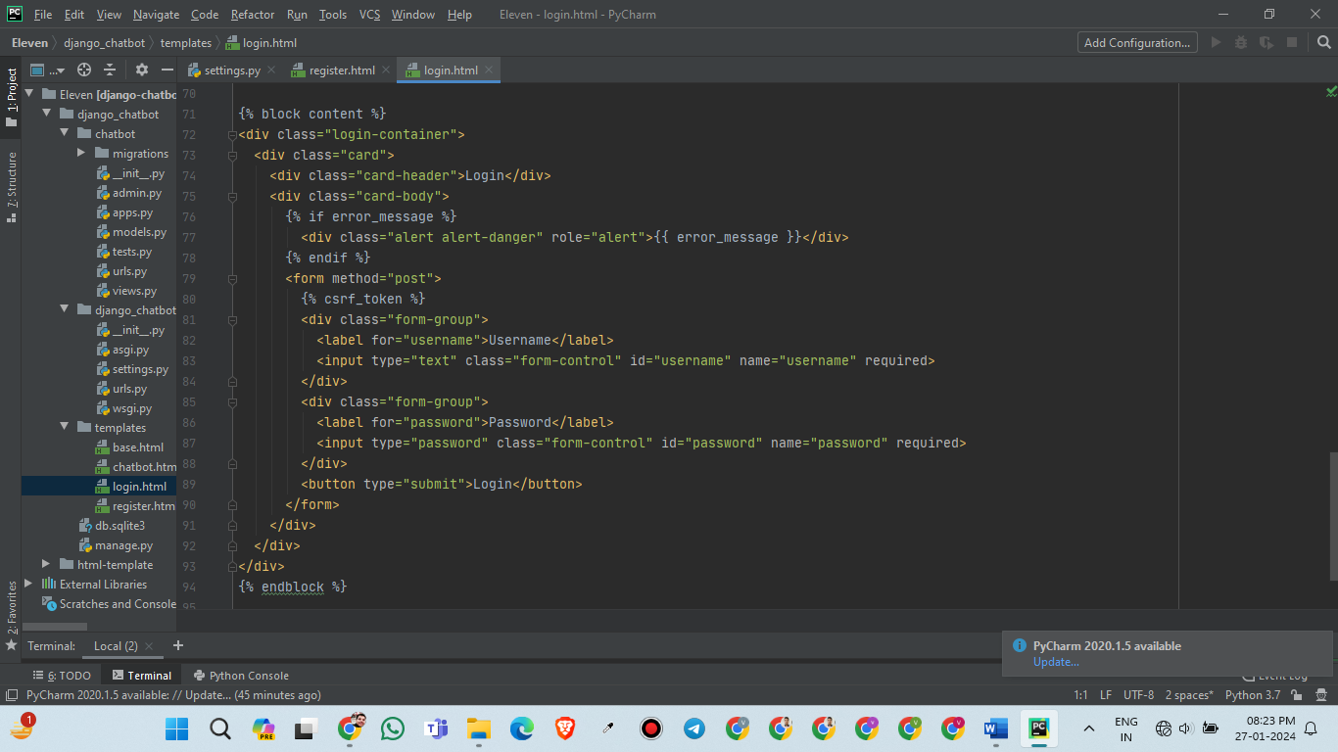
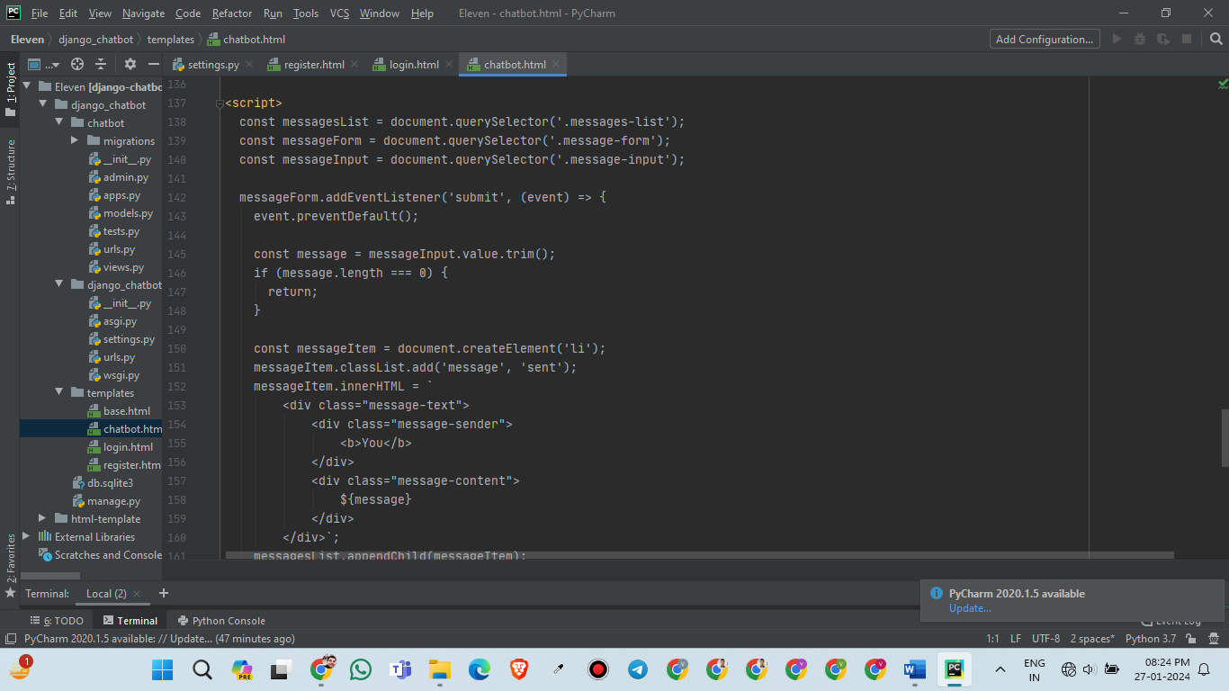

7. FUTURE SCOPE

The future scope of ChatGPT looks promising and expansive. Here are a few potential areas for its development:
1. Improved Language Understanding: ChatGPT could be further fine-tuned to understand complex and nuanced meanings, including slang and idiomatic expressions, making it more proficient in natural language understanding.
2. Multilingual Support: Expanding ChatGPT to support multiple languages would make it accessible and useful to a broader global audience. This would involve training the model on diverse language datasets and fine-tuning it for each language.
3. Domain-Specific Versions: Developing domain-specific versions of ChatGPT would allow for more specialized conversations in various fields, such as healthcare, law, finance, or technology. These versions could be tailored to provide accurate and reliable information within specific professional contexts.
4. Contextual Memory and Long-term Conversations: Enhancing ChatGPT's ability to maintain context and recall previous interactions within a conversation would greatly improve its usefulness. This would enable the model to engage in more in-depth discussions and maintain continuity across multiple interactions.
5. Ethical Considerations: Building upon the ongoing efforts to address biases and ethical concerns, future development could focus on ensuring that ChatGPT adheres to principles of fairness, inclusivity, transparency, and accountability.
8. CONCLUSION

In conclusion, the ChatGPT clone app is a valuable tool that utilizes the power of artificial intelligence to provide users with a conversational experience. It has the ability to understand and respond to a wide range of queries and conversations, making it useful for various purposes such as customer support, information retrieval, and entertainment. One of the key strengths of the ChatGPT clone app is its ability to generate human-like responses, which enhances the user experience and creates a more engaging conversation. It uses a large dataset to learn from a vast amount of information, allowing it to provide accurate and relevant answers to user queries. The app also offers the advantage of time efficiency, as it can handle multiple conversations simultaneously without any delays. This makes it useful for businesses that require quick responses to customer inquiries or for individuals seeking immediate information.
9. REFERENCE

- https://www.python.org/
- https://www.djangoproject.com/
- https://playground.openai.com/
- https://www.chat.openai.com/
- https://www.cleverbot.com/

